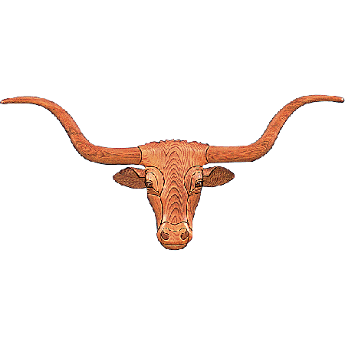
HUDSON-VALENTINE
Vegas Style

Texas Longhorn Breeder,

We have an exciting and innovative opportunity. Hudson-Valentine will be hosting the first ever Longhorn Sale in Las Vegas, Nevada. “The Hudson-Valentine Vegas Style” event will be held in conjunction with the High Roller Reining Classic Horse Show. As part of the “High Roller Event” we will be combining the nations Premier Horse Breeders with our Leading Longhorn Breeders, at one venue. To be held at The South Point Hotel, Casino and Spa, on September 19, 2015. We hope that you take advantage of this unique event to gain exposure for our “Texas Longhorns”. This chance to offer cattle to a new demographic is an exciting, modern idea and must be incorporated to promote our passion; raising and marketing Texas Longhorns.

Hudson-Valentine Vegas Style will be held at the South Point Hotel, Casino and Spa’s Equestrian Center. http://www.southpointcasino.com/. This facility will be the perfect place to display and sell Texas Longhorns. Not only does this venue offer sprawling arena but also offers wonderful restaurants, spa, entertainment, movies, bowling, casino and much more.

We are asking for your best, your favorite or your most spectacular longhorn females. Horn, pedigree and color need to be outstanding as we are expecting this sale to break all the records. Please submit your consignments for consideration by June 7th. You will need to email a photo, pedigree and horn measurement for consideration to HVLonghorns@gmail.com.

Cattle hauling will be arranged for your convenience at reduced prices. We will offer pick up sites conveniently located throughout the United States for easy accessibility. Bruce McCarty will once again be leading our auction to achieve the best prices.

Evaluate your herd to find the best females that showcase your hard work and breeding efforts. Come and be a part of this sensational event.

We are thrilled to offer another amazing Hudson- Valentine Sale, Vegas Style!

Best Wishes,

Bill and Elizabeth Hudson Lorinda Valentine

